


G H Patel College Of Engineering & Technology
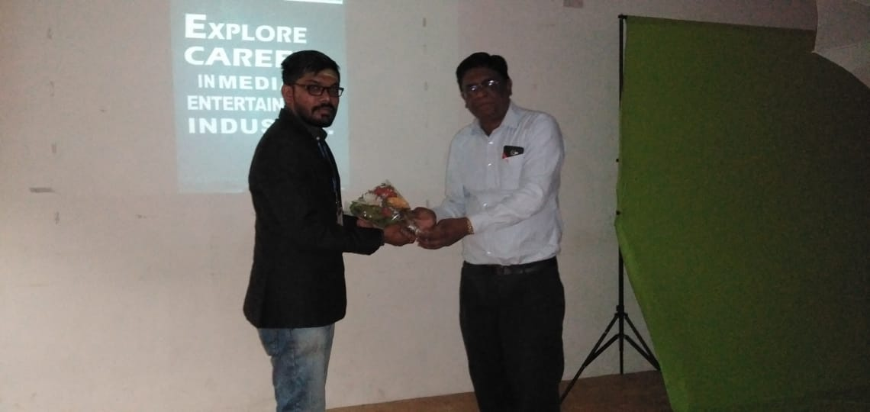
International Society Of Automation
Report-VFX Workshop
DATE:30/1/2019
ISA GCET Student Branch had organized a workshop on VFX on 30th January,2019 at GCET seminar hall. The event commenced on 12:00 P.M. as all the seats in the seminar hall were occupied including the honorary presence of Professor Jatin J Patel(Advising Faculty Member)and Professor Sneh Vyas(Organizer Faculty Member).
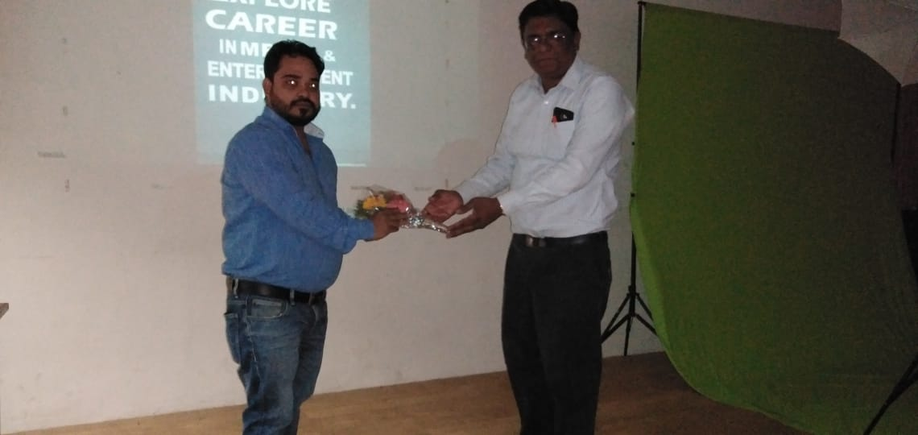
The session started with the felicitation of our chief guest Mr.SHEKHAR TIWARI(Phd from Cambridge University, 6 years experience in filmline and 8 years experience in teachingVFX, owner of renowned pixelcube academy)

and Mr. MIHIR RANA(B.C.A. graduate from SPU in 2008, has completed specialization in animation from Arena Animation in 2010) who were also going to conduct the session, from the hands of Professor Jatin J Patel(Associate professor- Electrical Department, Faculty Advisor of GCET ISA SB) .

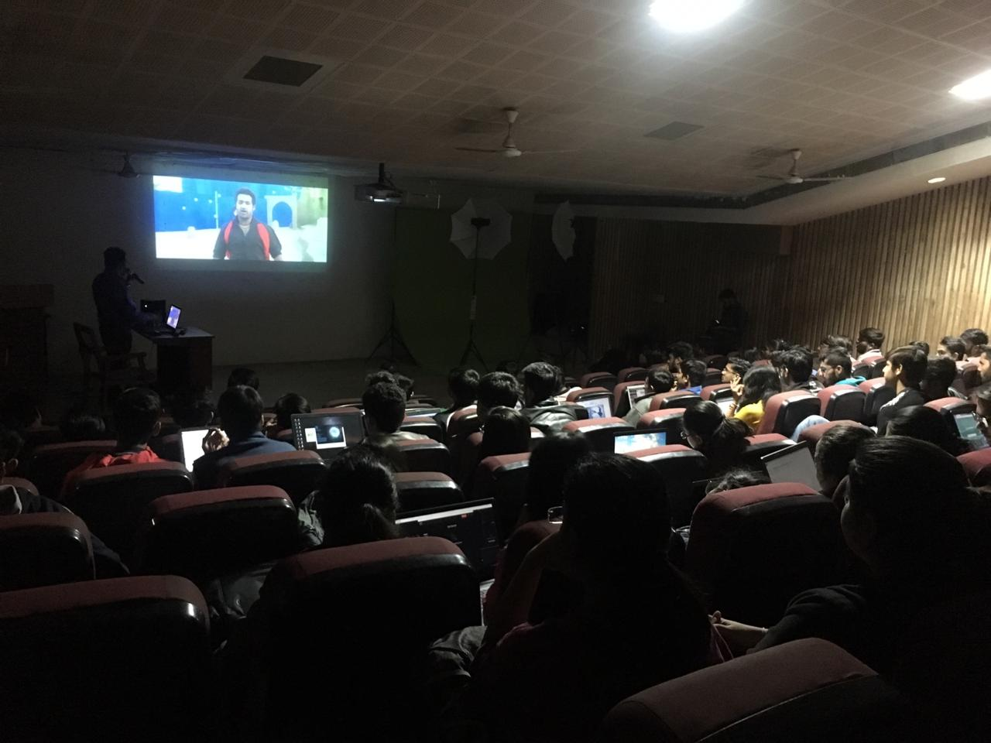
Mr.Shekharstarted by showing some of the clips from various Hollywood, Bollywood and South Movies in which VFX was involved and provided guidance in between to acknowledge the participants what were the tricks done and where were it done to make the things look realistic.

After showing some of the very fantastic VFX he had done, he provided the guidance of various softwares that where a need for using a particular softwarearises, wheather it’s Photoshop ,Aftereffects,Maya, 3DS MAX or Adobe Premiere.
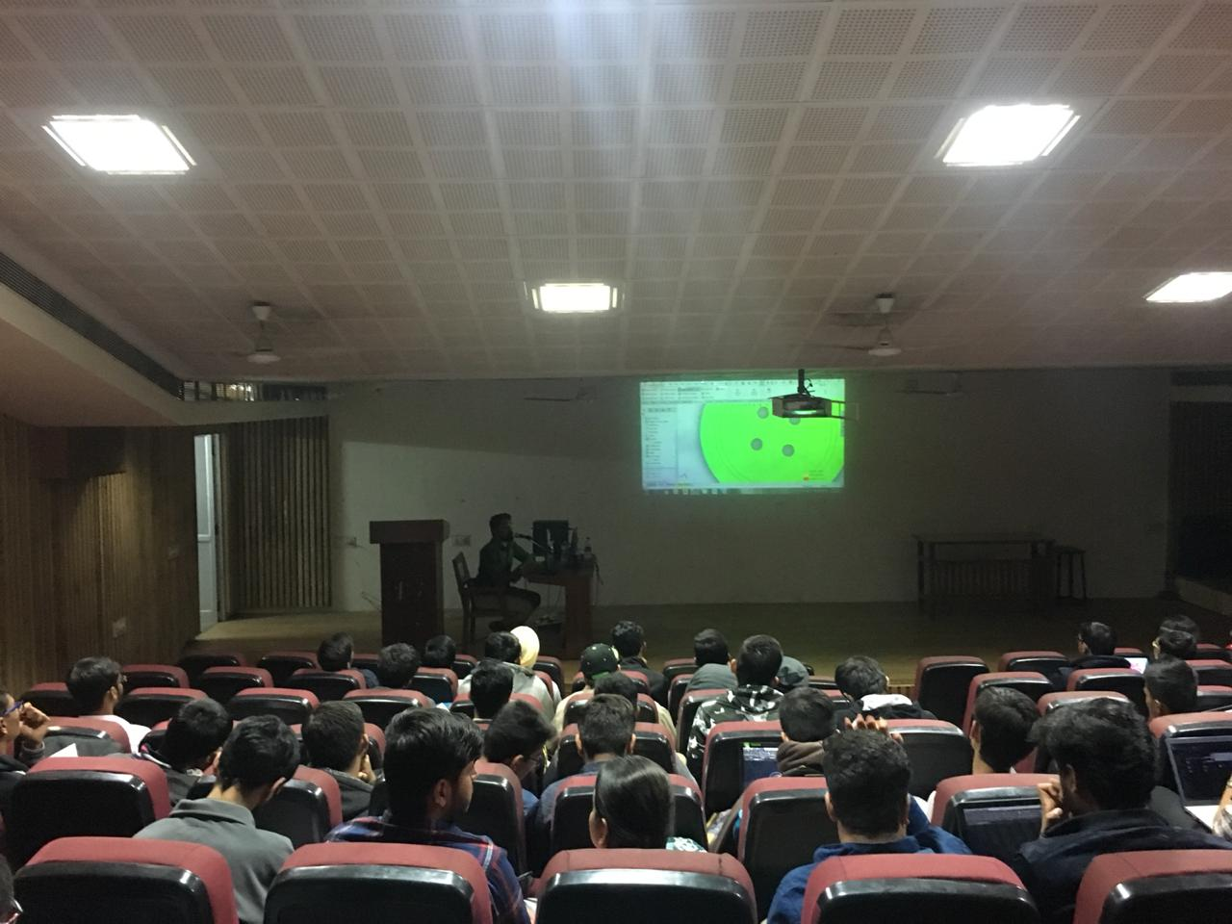

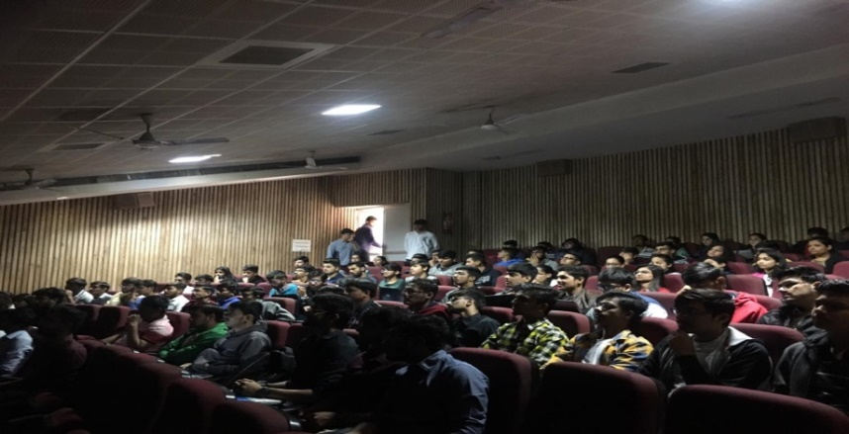
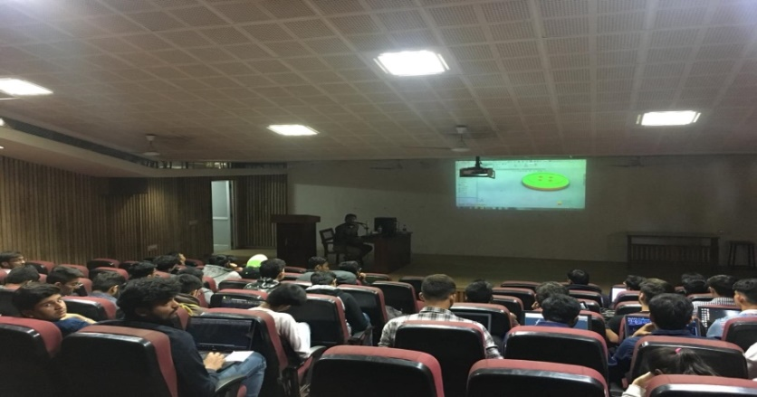
Then he showed some real work which was asked to him by the producers and how he had completed that assignment by using nuke software. Then there was a question –answer session in between where various good questions were asked by the participants whose answers were given by the expert by utmost interest. Then he shared very fruitful knowledge about the scope and career in the VFX industry.

After that, the most awaited session came of creating the live VFX .i.e. to shoot from the camera and to convert it into vfx. The expert created two scenes : one was of creation of double role and the other scene was generated on the chromecast and by changing the background a scene was created. Mr. Mihir ended the session by showing some usage of important tools.
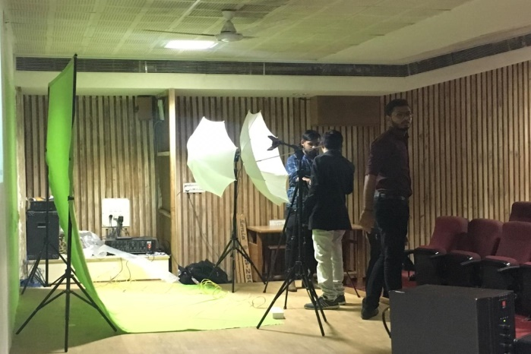
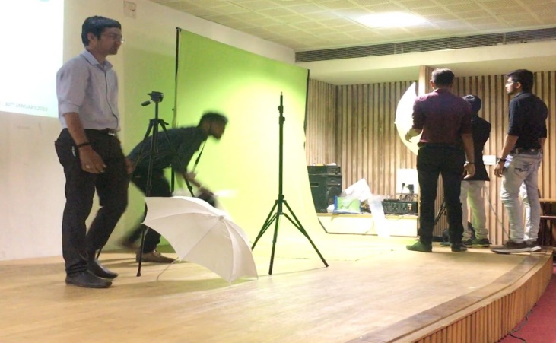

At last for a very meritorious session , Mr. Shekhar was provided Letter Of Appreciation from Web Master of ISA GCET SB and Coordinator of the event Ms. AnkitaMaheshwari
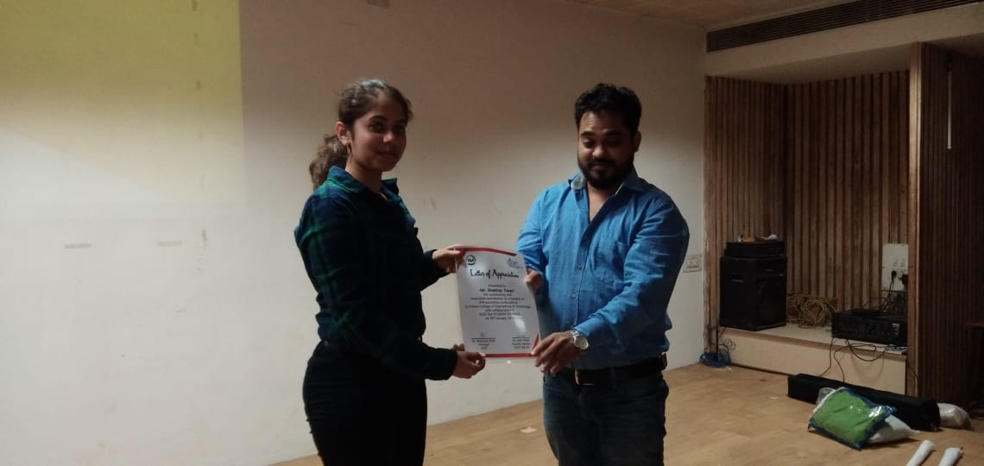

Mr. Mihir Rana was provided Letter Of Appreciation from Design Head and event coordinator Ms. Shreya Patel.

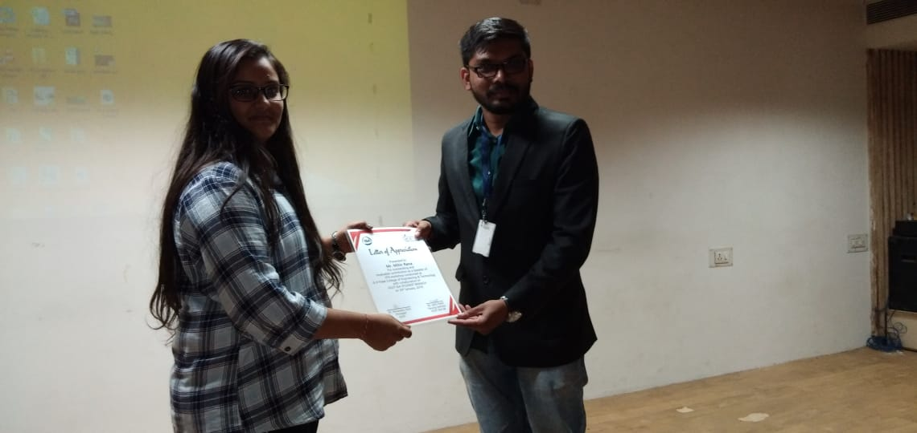

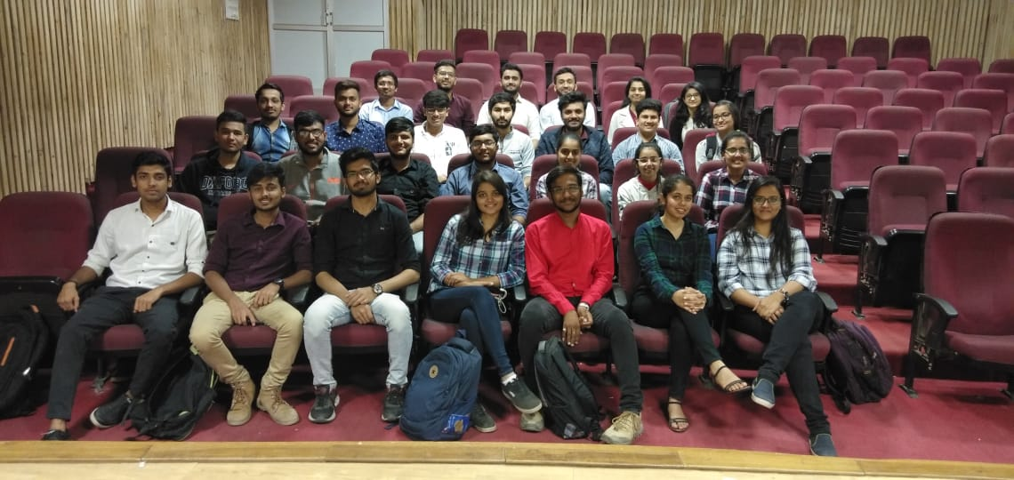
As a measure of protocol ISA took feedback of the participants for the idea of conducting such events in the future. Participants revealed a very positive

response and showed enthusiasm for such events in future. High Tea and Snacks were served and Certificates were distributed to mark the end of day having wonderful contribution from all the volunteers to make this event a success.

